**Daniel Williamson**

**Project #8**

**11/21/16**

**CS 212**

[**http://cefns.nau.edu/~daw277/index.html**](http://cefns.nau.edu/~daw277/index.html)

Project Overview

Purpose:

The purpose of this project was rather difficult. A lot of reviewing, reading online and referring to classmates, namely Joseph Remy. The reason for this project was to create a messaging system that would allow users to send a message between one another. While being logged on any user can message any other user. They have a choice to mark a message as read and/or delete a message.

Approach:

To begin, I knew I had to create a new php file, so I made a messages php file for my messaging page. This file will only be accessible if the user is logged in. So obviously we make sure to check if the user is logged in. If the user is logged in, we set up the message board with my typical header and footer. I made it dynamic in the previous project to make it easier to edit the header. Because in the header, you will also be notified if you have any pending messages with a number next to the message tab. Having it all the same, makes editing this easier, and less code. Next, we finally have the actual messaging area. You are asked for a user to message and what your message is going to be. You simply enter in whatever user you wish and a message, and hit send. If the user does not exist it will display a message saying that user does not exist. If for any reason the message fails to send, as a safety measure I have made it give you an error message and kill the request. Now, if you are sent a message, it will display below the messaging area. It will display the messages you have sent and the messages you have received. On the messages that you have received you will have the choice to mark them as read and/or delete. If you have a message you have sent, you can delete it. Which also deletes it on the user you sent it too side. These messages will be placed in newest at the top to the oldest at the button.

Results

These are my results:

This is what the message page looks like:

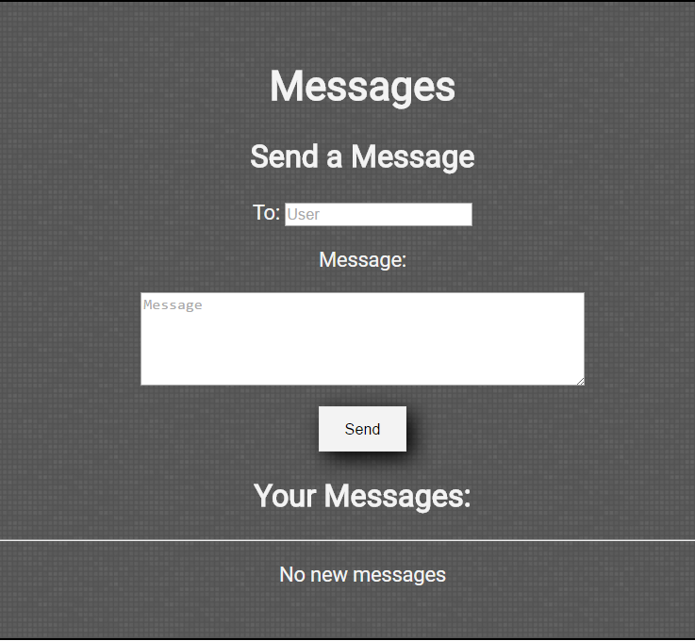

This is what the notification bar looks like if you have a message unread:

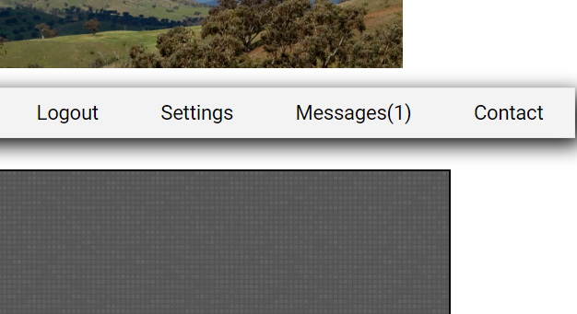

This is a message that was sent from a user to myself:

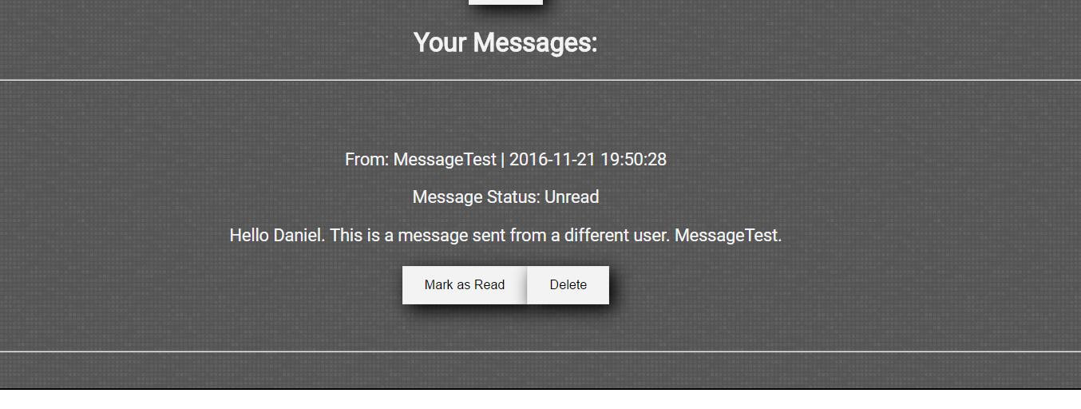

And after marking it as read:

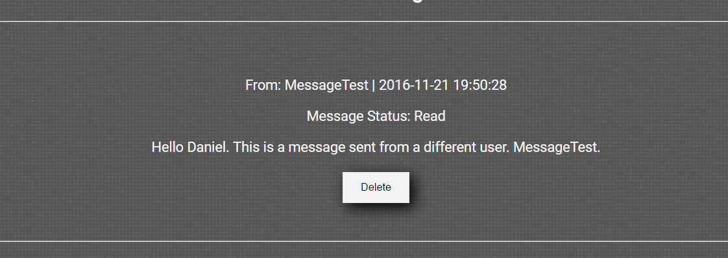

If you send a message and the user has not marked it as read:

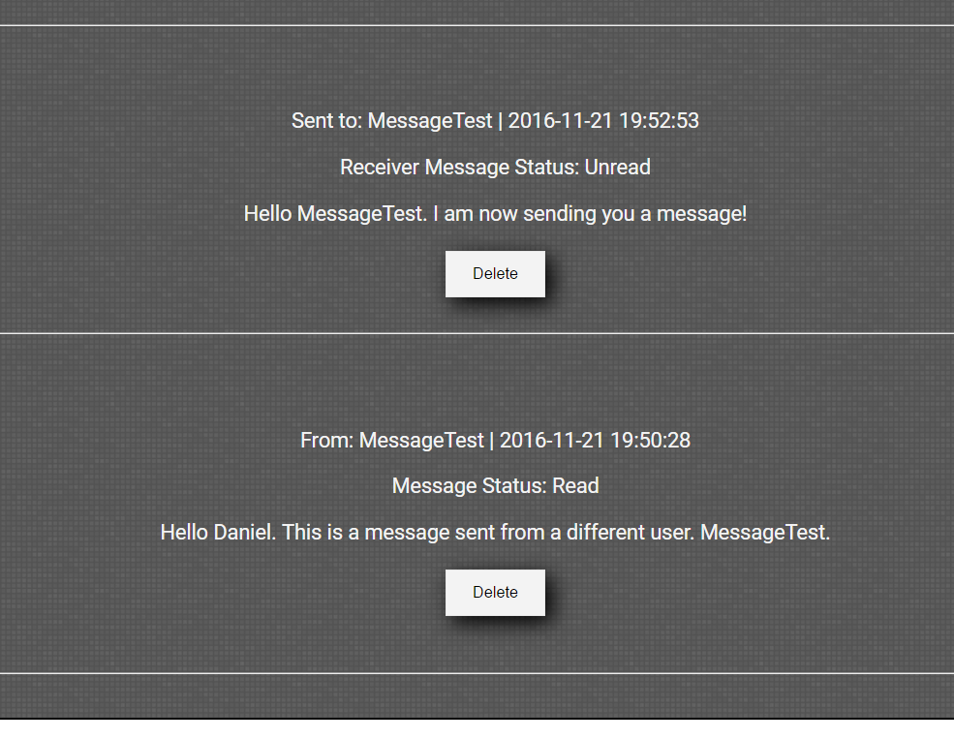

After the user you sent it to marks it as read:

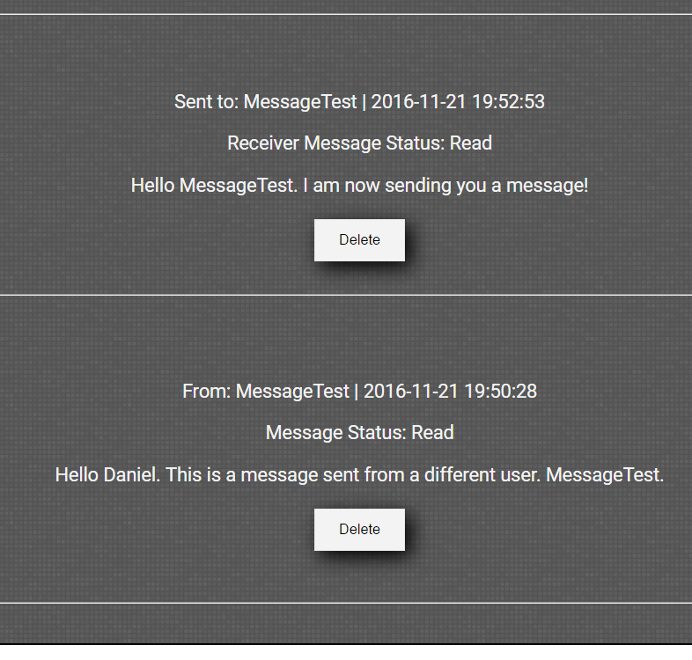

If you send a message to a user that does not exist:

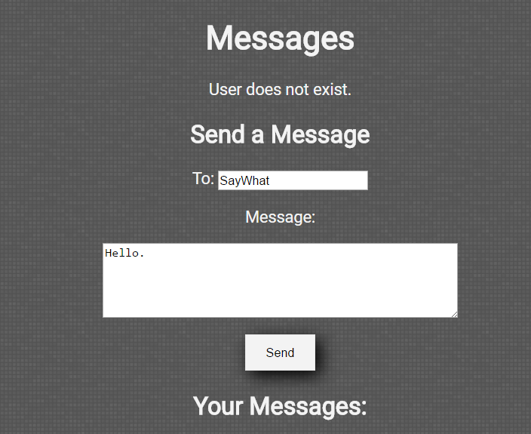

You can’t send a message to yourself:

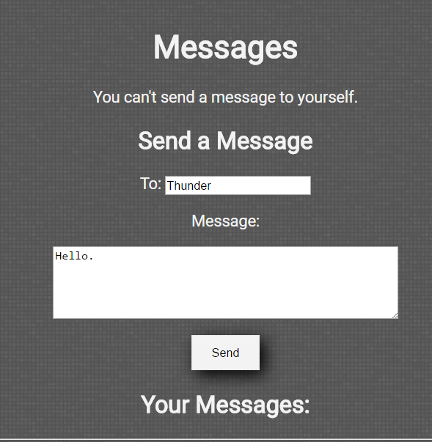

Conclusion

In conclusion, this was a difficult lab. Not as difficult as the previous lab, it had less code. But as always I learn more about PHP each time. The most difficult part was making the while loop was set up correctly to print out the messages that need to be displayed to the user.